When: Thursday 29th September 2016
Castlebar/Manulla Table Tennis Registration
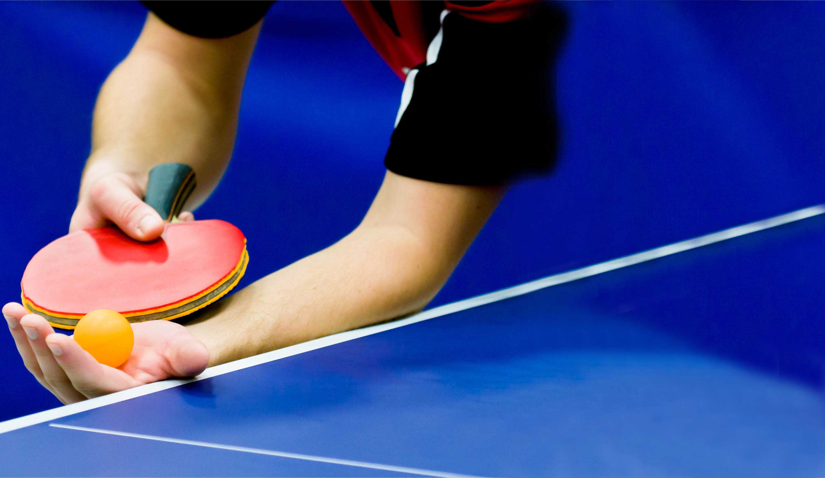
Time: 7pm- 8:30pm
Where: Manulla Community Centre
Cost: €20 registration fee for 2016/17 season, sessions €4 per person

